Abstract

This paper investigates the genetic diversity of three separate koala populations based on their microsatellite genotypes. Two of the populations are Victorian Koalas at two different locations and the third are Queensland Koalas in a US Zoo. The results supported that the Queensland Koalas were different from the Victorian Koalas, having a higher genetic diversity. The Victorian koalas were not statistically different and were nearly identical to each other. The data supported the hypothesis that the Victorian Koalas and Queensland Koalas would be genetically different based on their microsatellite haplotypes at 13 different loci.

Introduction

Koala populations in Australia have declined heavily in the past 100 years. Due to this decline, it is anticipated that their genetic diversity has also declined. The populations that were remaining were relocated and protected against the hunters driving them towards extinction. Some of these relocations included populations as small as 2 individuals resulting in massive bottlenecks and reduced genetic diversity. Due to this, it’s assumed that inbreeding was very high, and heterozygosity is likely very low.

Translocation may lead to interbreeding between the Northern Australian Koalas and the Southern Australian Koalas, which are considered to be two different species. One of the two population origins of the *Phascolarctos cinereus* present in the data in this experiment was Queensland, which has an estimated population decline of 53% over the past three years, and is expected to remain constant over the next three years as of 2016 (Adams‐Hosking et al. 2016).

This study will focus on the genetic diversity of three different koala subpopulations based on the number of polymorphisms at 13 different loci. Understanding their genetic diversity is critical to planning a conservation program that is effective. The genetic diversity of the three subpopulations will be determined by using previously collected data from the Ruiz-Rodriguez study. The use of microsatellite markers to determine polymorphisms at different loci will determine the genetic diversity of the three groups. By using figures created in R and a t-test the number of different polymorphisms will signify if there is a significant difference between the genetic diversity of the three different subpopulations (Ruiz-Rodriguez et al. 2016).

Materials and Methods

73 separate koalas were studied with the use of 4 microsatellite markers and 13 primer pairs. Three separate groups of koalas were studied from the following areas: Brisbane Ranges in Victoria Australia, Stoney Rises in Victoria Australia, and a US Zoo in which the koalas were originally from Queensland Australia. The PCR set up and algorithm used in this study was set up by (Ishida et al. 2011) and used on African Elephants initially. In this research done by Ruiz-Rodriguez, some of the microsatellite markers were being used for the first time including Phci21, Phci23, Phci24, and Phci30 (Ruiz-Rodriguez et al. 2016). The data collected included the sampling locations, the state of origin, the microsatellite markers, and their microsatellite genotypes in Microsoft Excel. The excel file was read into R software using the readxl package. By creating averages for each genotype based on its location and microsatellite markers we can determine which populations had the most and least genetic similarity. R software was then used to make visual representations of this data, this was done via the ggplot2 package. Lastly the same software was used to statistically compare the data sets, with the use of a t-test to see if the difference is large enough to be deemed statistically significant. Three separate T-tests were ran the first between the Brisbane Ranges and Stony Rises genotype data, the second between the Brisbane ranges and US Zoo genotype data, and the last between the Stony Rises and US Zoo data.

Results

Figure 1- Average Microsatellite Genotypes of the Koalas from Three Different Locations at Thirteen Different Loci (The x-axis signifies which subpopulation. The y-axis shows the average number of polymorphisms across 13 loci.)

Figure-2

Average of Microsatellite Genotypes at 13 different Loci for the Brisbane Ranges Population (The x-axis shows each of 13 loci. The y-axis shows the average number of polymorphisms across the subpopulation at each loci.)

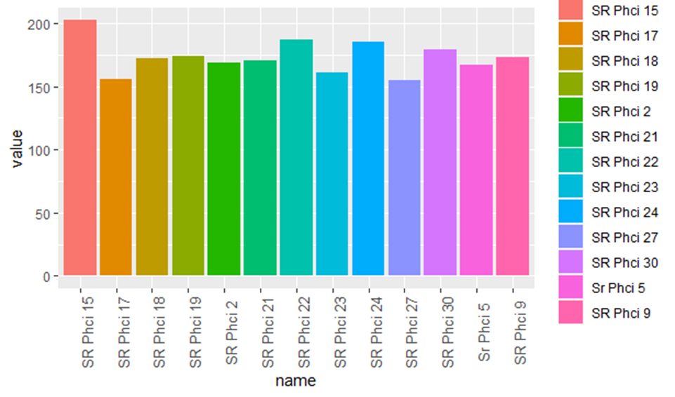

Figure-3

Average of Microsatellite Genotypes at 13 different Loci for the Stony Rises Population (The x-axis shows each of 13 loci. The y-axis shows the average number of polymorphisms across the subpopulation at each loci.)

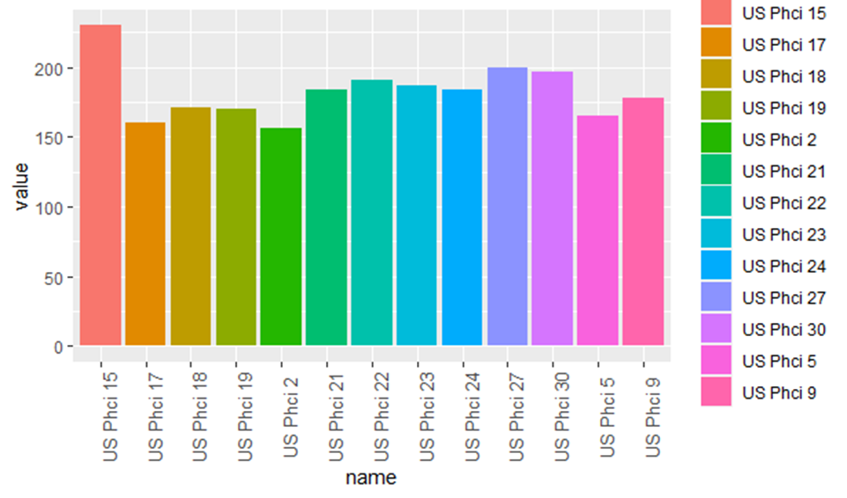

Figure-4

Average of Microsatellite Genotypes at 13 different Loci for the US Zoo Population derived from Queensland (The x-axis shows each of 13 loci. The y-axis shows the average number of polymorphisms across the subpopulation at each loci.)

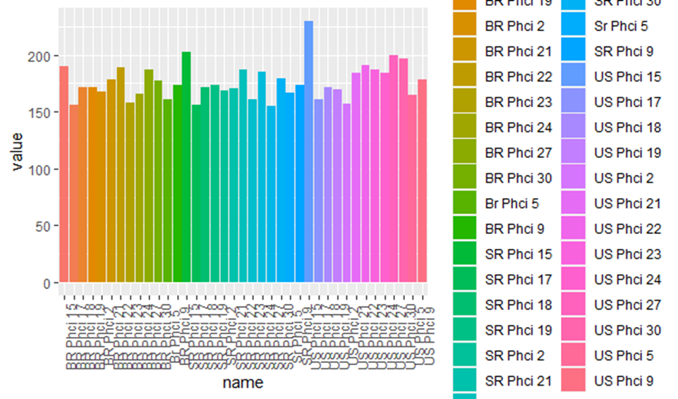

Figure-5

Average of Microsatellite Genotypes at each of 13 different Loci for all Three Populations (The x-axis shows each of 13 loci for three different subpopulations. The y-axis shows the average number of polymorphisms across the subpopulation at that loci.)

The average value of the microsatellite genotypes were 172.7 for the Brisbane Ranges, 173.2 for the Stony Rises, and 182.6 for the US zoo (Figure-1). Three T-tests were done using averages created at all 13 loci. The independent T-test for the Brisbane Ranges and Stony Rises resulted in the following data: t = -0.11031, df = 23.5, p-value = 0.9131. Implying that there is not a significant difference between the two data sets. The independent T-test for the Brisbane Ranges and the US zoo resulted in the following data: t = -1.5755, df = 19.233, p-value = 0.1314. Implying that there was a significant difference between the two data sets. Lastly, the independent T-test for the Stoney Rises and the US zoo resulted in the following data: t = -1.4309, df = 20.977, p-value = 0.1672, this data also implies a significant difference.

Discussion

By using the averages, figures, and T-tests it became clear that the US subpopulation was statistically and genetically different from the Brisbane Ranges and Stony Rises population. This makes sense considering the Stoney Rises and Brisbane Ranges are both Victorian Koalas and the US Zoo Koalas were brought in from Queensland. It also matches the results found by Ruiz-Rodriguez interpreting similar data (Ruiz-Rodriguez et al. 2016). However, it was surprising that the Queensland Koalas were more genetically diverse than the Victorian Koalas given previous research by Fowler (Fowler et al. 2000). It is possible that the controlled breeding in captivity promoted increased diversity and skewed the data compared to wild Queensland Koalas.

The US data at Phci 15 appears to be an outlier, however this was one of the highest values for all three genotypes and it was quite consistent through all of the koalas in that subpopulation (Figure-5). The low genetic diversity between the wild Victorian Koalas further supports their need for environmental protection in the wild. Environmental change like the recent fires will be very difficult for the wild koalas to endure given their lack of genetic diversity so protecting them and saving their environment could be very important. Also, the data supports the success of human interference in breeding. The US koala’s high genetic diversity may imply that similar programs may help the remaining koalas by introducing more genetic diversity back into the wild. The Queensland Koalas of Stoney Rises and Brisbane Ranges had lower genetic diversity than the US Koalas and were not statistically genetically different. The Queensland koalas in the US showed a significant genetic difference from the two sets of Victorian Koalas and increased genetic diversity.

Genetic diversity is very important because its understanding heavily impacts conservation efforts. It’s important to understand the source of the decreased genetic diversity and what can be done to help the koalas now and in the future. While hunting is a massive reason for the population decline, fragmentation may also affect the genetic diversity of subpopulations. The Queensland area is becoming highly fragmented, changing the natural population and potentially increasing inbreeding in these subpopulations with respect to the total population (Lee et al. 2010). Based on all of this data most would assume koalas had far more genetic diversity centuries ago than they have now. However, a 2012 study showed that the diversity in the mitochondrial DNA from centuries ago was nearly identical to the current diversity in mitochondrial DNA (Tsangaras et al. 2012). This suggests it is highly likely that an event prior to the recent decline in the koala population reduced their genetic diversity. This could be in some way related to its very specific diet of the toxic eucalyptus.

The koalas’ reliance on its diet heavily narrows the environments it can succeed in making environmental protection of the koalas’ homeland vital for its prolonged existence (Johnson et al. 2018). This is more important for Victorian Koalas than most subpopulations of the species. A 2017 study used mitochondrial DNA to compare the Victorian koalas of the South Gippsland area to other populations such as the Queensland population by comparing mitochondrial DNA and microsatellite genotypes. The results showed a significant difference between the genetic diversity of the South Gippsland Victorian Koalas and the other koala subpopulations tested (Wedrowicz et al. 2018). The research hypothesized that the Victorian Koalas increased genetic diversity would make them more likely to survive a change in the environment, like the recent fires, than a less diverse group.

The final open hunting season on koalas in the 1920s reduced the population size to approximately 20,000. 10,000 of which were located in the Queensland area, being the largest population, its lack of genetic diversity came as a surprise. Research in the year 2000 determined two hypotheses. That the lack of distribution of the central phylogenetic haplotype implies a bottleneck occurred at the north gold coast, and two highly divergent haplotypes at the Moreton site indicated multiple translocation events likely occurred (Fowler et al. 2000). As new information about genetic diversity becomes available legislation can be modified to improve the koala’s chances at survival and increase their numbers in the wild (Clark et al. 2000). Sexual selection may also play a role in the genetic diversity of the koalas, however little is known about this (Ellis et al. 2015). Furthermore, sexual behaviors seem to be quite constant between subpopulations somewhat dismissing the likelihood of this theory (Ellis et al. 2010). In conclusion, I hypothesize that the increased genetic diversity of the koalas at the U.S. Zoo is due to artificial mating patterns, and with more research as to how this occurred genetic diversity of the Koala populations at Stoney Rises and the Brisbane Ranges could be increased aiding the ongoing conservation efforts.

Works Cited

Adams‐Hosking C, McBride MF, Baxter G, Burgman M, Villiers D de, Kavanagh R, Lawler I, Lunney D, Melzer A, Menkhorst P, et al. 2016. Use of expert knowledge to elicit population trends for the koala (Phascolarctos cinereus). Diversity and Distributions. 22(3):249–262. doi:10.1111/ddi.12400.

Clark TW, Mazur N, Cork SJ, Dovers S, Harding R. 2000. Koala Conservation Policy Process: Appraisal and Recommendations. Conservation Biology. 14(3):681–690. doi:10.1046/j.1523-1739.2000.99390.x.

Ellis W, Bercovitch F, FitzGibbon S, Melzer A, de Villiers D, Dique D. 2010. Koala birth seasonality and sex ratios across multiple sites in Queensland, Australia. J Mammal. 91(1):177–182. doi:10.1644/08-MAMM-A-358R.1.

Ellis W, FitzGibbon S, Pye G, Whipple B, Barth B, Johnston S, Seddon J, Melzer A, Higgins D, Bercovitch F. 2015. The Role of Bioacoustic Signals in Koala Sexual Selection: Insights from Seasonal Patterns of Associations Revealed with GPS-Proximity Units. PLoS One. 10(7). doi:10.1371/journal.pone.0130657. [accessed 2020 Mar 31]. https://www.ncbi.nlm.nih.gov/pmc/articles/PMC4496073/.

Fowler EV, Houlden BA, Hoeben P, Timms P. 2000. Genetic diversity and gene flow among southeastern Queensland koalas (Phascolarctos cinereus). Molecular Ecology. 9(2):155–164. doi:10.1046/j.1365-294x.2000.00844.x.

Johnson RN, O’Meally D, Chen Z, Etherington GJ, Ho SYW, Nash WJ, Grueber CE, Cheng Y, Whittington CM, Dennison S, et al. 2018. Adaptation and conservation insights from the koala genome. Nat Genet. 50(8):1102–1111. doi:10.1038/s41588-018-0153-5.

Lee KE, Seddon JM, Corley SW, Ellis WAH, Johnston SD, de Villiers DL, Preece HJ, Carrick FN. 2010. Genetic variation and structuring in the threatened koala populations of Southeast Queensland. Conserv Genet. 11(6):2091–2103. doi:10.1007/s10592-009-9987-9.

Ruiz-Rodriguez CT, Ishida Y, Murray ND, O’brien SJ, Graves JAM, Greenwood AD, Roca AL. 2016. Koalas (Phascolarctos cinereus) from Queensland are genetically distinct from 2 populations in Victoria. The Journal of heredity. 107(7):573–580. doi:10.1093/jhered/esw049.

Tsangaras K, Avila-Arcos MC, Ishida Y, Helgen KM, Roca AL, Greenwood AD. 2012. Historically low mitochondrial DNA diversity in koalas (Phascolarctos cinereus). BMC Genet. 13(1):92. doi:10.1186/1471-2156-13-92.

Wedrowicz F, Mosse J, Wright W, Hogan FE. 2018. Genetic structure and diversity of the koala population in South Gippsland, Victoria: a remnant population of high conservation significance. Conserv Genet. 19(3):713–728. doi:10.1007/s10592-018-1049-8.